2024

LIPID MAPS® Data handling & Privacy Policy

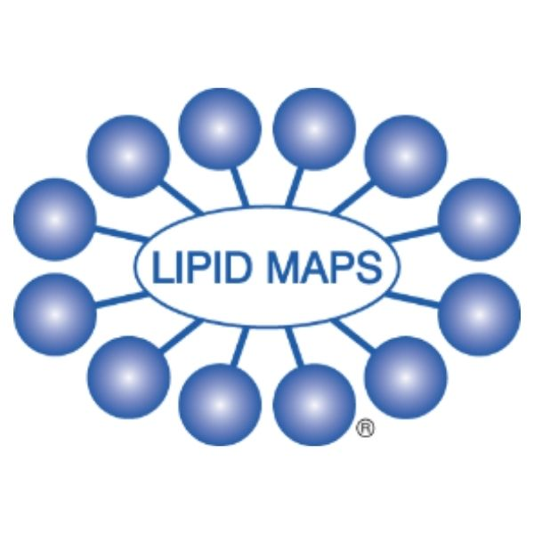

*LIPID MAPS is committed to protecting and respecting your privacy.*

This policy highlights the process for ensuring data received for LIPID MAPS is stored securely and how this data is handled. It sets out the basis on which any personal data we collect from you, or that you provide to us, will be processed by us. Please read the following carefully to understand our practices regarding your personal data and how we will treat it.

For the purpose of the UK General Data Protection Regulation (UK GDPR), the data controller is Cardiff University with the Babraham Institute as a collaborator, who house the LIPID MAPS servers.

**Collecting and using personal data**

The type of personal information we may collect from you and how we get it:

* Details that you provide directly by completing forms on our website, including name and email address. This includes information provided when contacting LIPID MAPS, reporting a problem, or subscribing to services we may offer.
* If you contact us via other methods, we may keep a record of that correspondence.
* We may also ask you to complete surveys to help us improve our services, although you do not have to respond to them.
* When you browse the website ([www.lipidmaps.org](http://www.lipidmaps.org)), we collect details of your visits to our site including, but not limited to, traffic data, location data, and other communication data, as well as the resources that you access.
* Cookies and analytics information that make our site easier to use and allow us to continue to improve our website. ([Read our Cookie policy](https://www.lipidmaps.org/cookie-policy)).
* We can collect information about your interests and browsing behaviour from Google Analytics, and social media providers such as X.

Under the UK GDPR, the lawful bases we rely on for processing this information are:

1. Your consent. You are able to remove your consent at any time by contacting LIPID MAPS.
2. We need it to perform a public task.
3. We have a legitimate interest.

Personal data is used for purposes for which it was provided only, by supplying this information, you are consenting to LIPID MAPS storing and using it for that purpose.

We may use information held about you in the following ways:

* To respond to your enquiries and keep a record of our communications with you.
* To ensure that content from our site is presented in the most effective manner for you and for your computer.
* To provide you with information, events, or services that you request from us or which we feel may interest you, where you have consented to be contacted for such purposes.
* To allow you to participate in interactive features of our service when you choose to do so.
* To notify you about changes to our site.
* To send you updates, information and newsletters if you request them.

We will not use your personal information to contact you unless you have specifically requested to receive information from us.

How to withdraw consent:

* If you would like to unsubscribe from any notification from LIPID MAPS you can unsubscribe at all any time by replying directly to the notification. Please note it may take a few days for the change to take effect.

Under data protection law, your data protection rights include:

* Your right of access - You have the right to ask us for copies of your personal information.
* Your right to rectification - You have the right to ask us to rectify personal information you think is inaccurate. You also have the right to ask us to complete information you think is incomplete.
* Your right to erasure - You have the right to ask us to erase your personal information in certain circumstances.
* Your right to restriction of processing - You have the right to ask us to restrict the processing of your personal information in certain circumstances.
* Your right to object to processing - You have the the right to object to the processing of your personal information in certain circumstances.
* Your right to data portability - You have the right to ask that we transfer the personal information you gave us to another organisation, or to you, in certain circumstances.
* Please contact us via the contact form <https://www.lipidmaps.org/about/contact> or [info@lipidmaps.org](mailto:info@lipidmaps.org) if you wish to make a request.
* You have the right to complain to the Information Commissioner’s Office (ICO)if you think your personal information has not been handled responsibly and in line with good practice - <https://ico.org.uk/make-a-complaint/data-protection-complaints/personal-information-complaint/>

**Storage and security**

Personal information you provide us is stored on securely. The transmission of information via the internet is not completely secure. We do our best to protect your personal data, but we cannot guarantee the security of your data transmitted to our site; any transmission is at your own risk. Once we have received your information via the methods detailed below, we will use strict procedures and security features to prevent unauthorized access.

1. Data pertaining to the Community forum / LIPID MAPS email address

Data will be stored on the Babraham servers and shared safely between the two institutions. Both Cardiff University and the Babraham Institute, Cambridge will be accessing data which comes through the LIPID MAPS website. This information will be intended to be retained in line with the end of the project.

1. Data pertaining to LIPID MAPS Training schools / Subscription information

Will be kept in Cardiff University on the One Drive under password protection. One Drive is a safe, secure network provided by Cardiff University. Cardiff University will be responsible for keeping this database accurate, including deleting and amending as required. This information will be intended to be retained in line with the end of the project.

1. Data pertaining to LIPID MAPS Contacts us form

Any Data that comes via the contact us form, is via email format only, and will only be kept until the query has been dealt with. After this time all personal data, (e.g., email address and contact name), will be deleted. Only the nature of the enquiry will be logged in order to keep track of queries and identify any particular trends etc.

This overall process will ensure there are 2 clear distinct databases. One held on the Babraham servers (1) and one database in Cardiff (2).

**Disclosure of your information**

The contact details you supply to us will not be shared with third parties. Only Cardiff University and the Babraham Institute will have access to your information and will only use your information between each other for the purpose intended.

Our site from time to time, contain links to and from the websites of our partner networks and affiliates. If you follow a link to any of these websites, please note that these websites have their own privacy policies and we do not accept any responsibility or liability for these policies. Please check these policies before you submit any personal data to these websites.

Changes to this privacy notice We may change this privacy notice from time to time. It is advised that you check the policy occasionally to ensure you are aware of the most recent version.

**Contact us**

For any further enquiries about this policy, please contact: [info@lipidmaps.org](mailto:info@lipidmaps.org)