IMPACT OF LIPIDOMICS ON OXIDIZED LIPIDS AND NON-ALCOHOLIC FATTY LIVER DISEASE:
LIPID MAPS Annual Meeting MAY 7-8, 2013

Tuesday, May 7 Scripps Seaside Forum - UCSD

7:15-8:30 AM – Registration and Breakfast Buffet / Poster Setup
8:30-8:45 AM – Welcome [Edward A. Dennis, Chair]
8:45-10:00 AM – Oxidized Lipids [Joseph L. Witztum, Chair]
- 8:45 Alan M. Fogelman (University of California, Los Angeles) – A novel strategy for oral ApoA-I mimetic therapy
- 9:20 Ned A. Porter (Vanderbilt University) – Free radical oxidation of sterols and sterol esters in vitro and in vivo
10:00-10:30 AM – Coffee Break
10:30-11:40 AM – Oxidized Lipids, Cont. [Dennis E. Vance, Chair]
- 10:30 Norbert Leitinger (University of Virginia) – The effect of oxidized phospholipids on macrophage phenotype and function
- 11:05 Ariel Feldstein (University of California, San Diego) – Oxidized metabolites of linoleic acid as biomarkers of liver injury in NASH
11:40-11:50 AM – Group Photo
11:50-12:50 PM – Lunch
12:50-1:50 PM – LIPID MAPS Advances [Stephen H. White, Chair]
- 12:50 Christopher K. Glass (University of California, San Diego) – Genomics and lipidomics of macrophage activation
- 1:20 David W. Russell (UT Southwestern Medical Center) – Genetic determinants of human plasma sterol levels
1:50-3:00 PM – LIPID MAPS Advances in Oxidized Lipids [G. Graham Shipley, Chair]
- 1:50 Joseph L. Witztum (University of California, San Diego) – Development of a novel reagent and murine models to study the role of oxidized phospholipids in health and disease
- 2:30 Edward A. Dennis (University of California, San Diego) – Eicosanoids in inflammation, infection, and oxidative stress
3:00-3:30 PM – Coffee Break
3:30-4:15 PM – Panel Discussion on Oxidized Lipids: Future Directions / Current
Roadblocks / LIPID MAPS Study [Joseph L. Witztum, Chair]
Panel: Alan M. Fogelman, Ned A. Porter, Norbert Leitinger and Ariel Feldstein.
4:15-4:45 PM – Lightning Talks from Poster Abstracts (see next page for talk titles)
4:45-6:45 PM Poster session & Reception
{ 5:15-6:15 PM – Oxidized Lipids Discussion [Edward A. Dennis, Chair] }
Advisory and Operating Committee members only
6:45-8:00 PM – Dinner

Lightning Talks (Tuesday, May 7, 4:15-4:45 PM)

Oxidized Lipids
- 4:15 Catherine F. Clarke (University of California, Los Angeles) – Inclusion of small amounts of isotope-reinforced polyunsaturated fatty acids suppress lipid autoxidation
- 4:20 Jean-Marie Galano (Universites de Montpellier, France & INRA, France) – DHA dose-dependently reduces atherosclerosis: a putative role for its peroxidation metabolites, F4-neuroprostanes
- 4:25 James R. Springstead (University of California Los Angeles, CA / Western Michigan University) – Epoxyisoprostane-containing lipids regulate the inflammatory pathway in endothelial cells
Non-Alcoholic Fatty Liver Disease
- 4:30 Yajing Chu (University of Cambridge, United Kingdom) – Using metabolomics to investigate the induction of non-alcoholic fatty liver disease in a rat model of hepatocellular carcinogenesis
- 4:35 Kavya Anjani (INSERM, France) – NASH associates with a Phospholipid pattern in morbidly obese female
- 4:40 José M. Mato (CIC bioGUNE, Spain) – The signature biomarker lipids of NASH and identification of a novel pathway for hepatic triglyceride synthesis
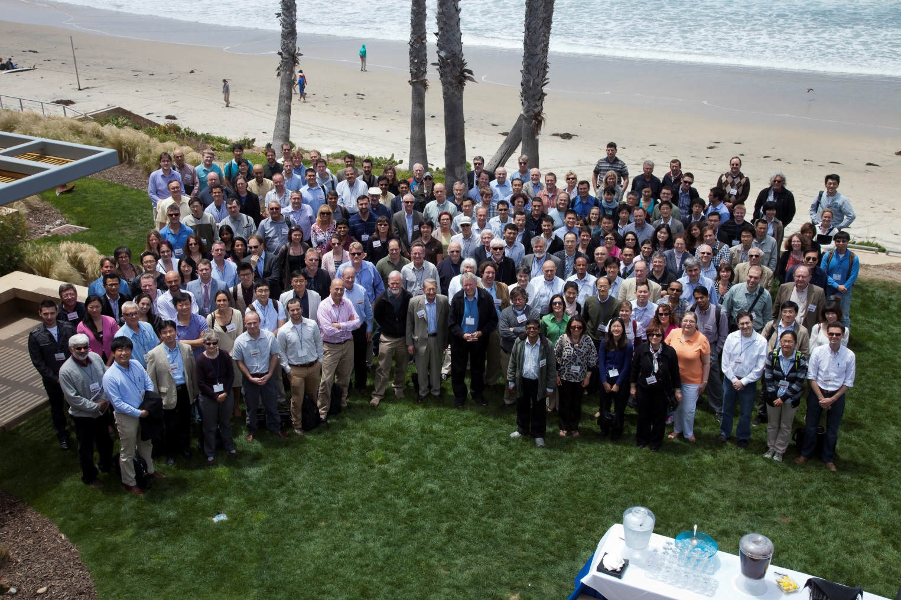

2012 LIPID MAPS Meeting Photo by Megan O’Connor

LIPID MAPS Meeting 2009
Wednesday, May 8 Scripps Seaside Forum - UCSD
7:45-8:30 AM – Breakfast Buffet
8:30 - 10:15 AM – Non-Alcoholic Fatty Liver Disease [H. Alex Brown, Chair]
- 8:30 Helen Hobbs (UT Southwestern Medical Center) – Nature + Nurture = NAFLD
- 9:05 Jay Horton (UT Southwestern Medical Center) – Molecular pathways leading to hepatic steatosis
- 9:40 Arun Sanyal (Virginia Commonwealth University) – Lipidomic insights on disease progression in NAFLD: Readouts from mice and men
10:15-10:45 AM – Coffee Break
10:45-11:50 AM – Genetic Effects [Susan A. Henry, Chair]
- 10:45 Benjamin F. Cravatt III (The Scripps Research Institute) – Mapping lipid pathways in mammalian biology by chemoproteomics and metabolomics
- 11:20 Ziqiang Guan (Duke University) – Prenols as biomarkers for genetic diseases
11:50 AM-1:50 PM – Lunch and Poster session
1:50-2:50 PM – LIPID MAPS Advances [Alan Aderem, Chair]
- 1:50 Robert Murphy (University of Colorado Denver) – Advances in mass spectrometry applied to lipid biochemistry
- 2:20 Alfred Merrill (Georgia Institute of Technology) – Sugar and fat: Methods, interesting findings, and remaining challenges for analysis of the (glyco)sphingolipidome
2:50-4:00 PM – LIPID MAPS Advances in NAFLDs [Shelagh Ferguson-Miller, Chair]
- 2:50 D. Lee Gorden (Vanderbilt University) – An emerging epidemic: Steatohepatitis and progression toward liver cancers
- 3:25 H. Alex Brown (Vanderbilt University) – Molecular biomarkers in NAFLDs: An overview of the NASH study conducted by the LIPID MAPS Consortium
4:00-4:45 PM – Panel Discussion on NAFLD: Future Directions / Current Roadblocks / LIPID
MAPS Study [H. Alex Brown, Chair]
Panel: Jay Horton, Benjamin F. Cravatt III, Arun Sanyal, and D. Lee Gorden

4:45 PM – Closing Remarks and Adjournment
{ 5:15-6:15 PM – NAFLD Discussion [Edward A. Dennis, Chair] }
Advisory and Operating Committee members only

Thursday, May 9 La Jolla Shores Hotel

7:30AM – Breakfast Buffet – LIPID MAPS Operating/ Steering Committee members only
8:00-10:30AM – OPERATING COMMITTEE MEETING
Committee members only
10:30AM – 11:30PM – STEERING COMMITTEE MEETING
Committee members only

